Login system

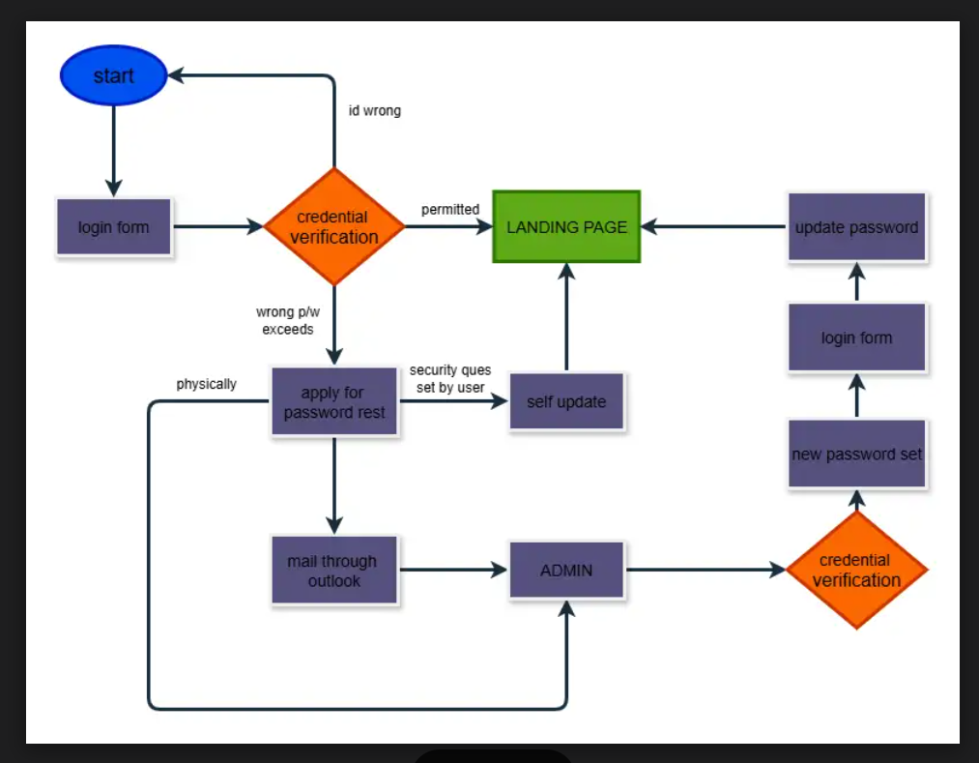

<https://drive.google.com/file/d/1lO7rQRjS48pAlGyjQnibIUQbXtbVjE5n/view?usp=sharing>